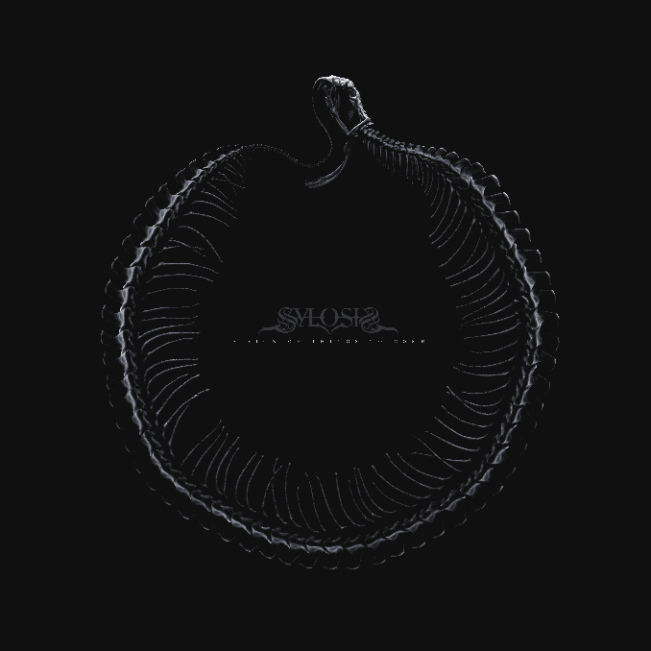

SYLOSIS
‘A Sign Of Things To Come’

OUT: September 8th 2023
Josh Middleton | vocals, guitar  Alex Bailey | guitar  Conor Marshall | bass  Ali Richardson | drums | Sylosis-band.com  Facebook.com/Sylosis  Twitter.com/Sylosis  Instagram.com/sylosisofficial
The tides swell as the next wave of British metal continues to build momentum, led by genre pioneers, SYLOSIS and their brand-new opus, A Sign Of Things To Come.

From the fiery modern thrash of 2008 debut Conclusion Of An Age and its epic follow-ups, Edge Of The Earth (2011) and Monolith (2012), to the direct, holistic savagery of 2015’s Dormant Heart and 2020’s much-acclaimed Cycle Of Suffering, Sylosis have proudly flown the flag for fiercely sophisticated but defiantly uncompromising metal. Now armed with new music, Sylosis is to make a mighty reintroduction into the international metal world!

“My approach on this record has been to rediscover what I loved about metal when I first discovered it!” recalls Josh Middleton. “That’s the feeling I wanted to capture on this record – imagining the first time I plugged into my amp and cranked the volume at band practice; so powerful and energising. I think you can feel that on this record!”

The sixth full-length in the Sylosis catalogue, A Sign Of Things To Come is instantly recognisable as the most potent and powerful of the band’s career. Comprising ten concise and crushing metal anthems, the new record covers a huge amount of musical ground while simultaneously delivering several metric fuck-tons of Middleton’s trademark, ripping riffs. Notable for being the shortest Sylosis album to date, A Sign Of Things To Come is also the band’s best: from the all-out thrash war of the opening ‘Deadwood’ and the snarling, groove metal fury of ‘Pariahs’, to the lurching sludge and sublime chorus payoff of ‘Eye For An Eye,’ and ‘Thorns’ shimmering, gothic doom vibes, the phrase “all killer, no fucking filler” has never been more applicable. Ten songs, ten triumphs: mission accomplished.

“I’m a big fan of progressive and long albums, but I was ruthless on myself during the writing process,” says Josh. “Song selection was important, making sure everything had a place and purpose to serve the album. I spent a lot of time listening back to those classic records, hearing how the anthemic elements were brought through, alongside crushing riffs. Something like Pantera’s Far Beyond Driven, Metallica’s Black Album and Slipknot’s Iowa…anthemic, intense and heavy!”.

Fans of neck-breaking musical carnage will have plenty to get excited about when A Sign Of Things To Come is finally unleashed. With the band’s current line-up of Josh Middleton (guitar/vocals), Alex Bailey (guitar), Ali Richardson (drums) and Conor Marshall (bass) audibly clicking into a higher gear, the new Sylosis album pushes and pulls with a newfound sense of dynamics, as showcased most pointedly via the melodic, post-industrial atmospherics of ‘Absent’ and the haunting, epic depths of ‘A Godless Throne.’ Furthermore, each one of these ten new songs stakes a claim to being the best thing Josh Middleton has ever written. Co-produced with revered studio maven Scott Atkins (Amon Amarth/Cradle Of Filth), and sonically monstrous as a result, A Sign Of Things To Come represents the pinnacle of this band’s creative endeavours.

“As far as songwriting goes, I’ve just got better at it over time” Josh notes. “Some people get older and their tastes mellow, and mine just don’t! I’m a lifer for heavy music, so I never want to overdo the melodic side of Sylosis, but there’s just enough on this album to keep people on their toes and mix things up with a new approach, both to the songwriting and performance in the studio. This is the first time I’ve allowed myself to be produced; taking on some brutal criticism and pushing myself to deliver the best vocal performance of my career.”

Always one of modern metal’s most thoughtful and eloquent bands, Sylosis could hardly create a new album without reflecting the landscape of the world in some form or other. A Sign Of Things To Come has no central theme, although is a commentary from the point of Josh Middleton:

“As a father of two, it’s hard to be happy with the state of the world that my daughters will have to inherit. More than ever, we live on a divided planet, now amplified by technological advancements that seemingly push us further away from one another, whilst corporations and politicians exploit the planet and people…I don’t see how humans come out of this well…but as I say in the song, ‘I want to say that maybe I’m wrong’, and I do want to be able to say that one day!”

Sylosis are back to remind everybody what real heavy metal sounds like when executed by the best of the best. Having been denied the chance to tour in support of Cycle Of Suffering, the fire is well and truly lit ahead of a career defining album cycle ahead!

